Pleasant Grove Presbyterian Church
1660 Pleasant Grove Road
Chester, South Carolina 29706
www.pgchester.org

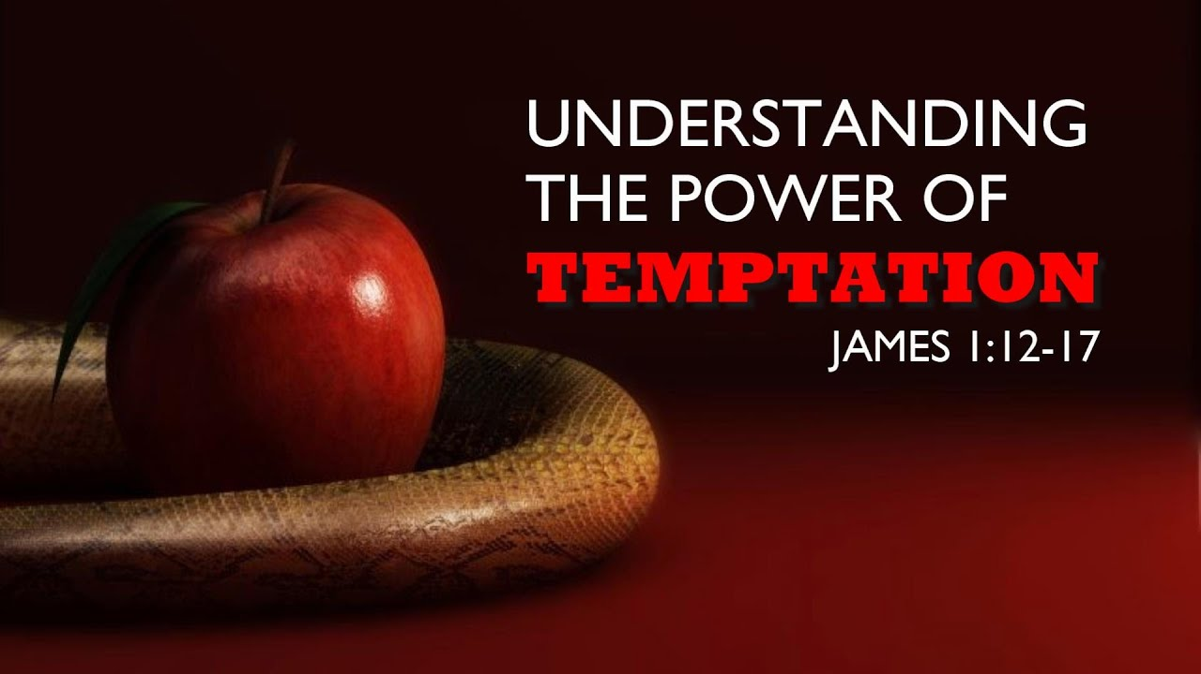

May 28, 2023
Pleasant Grove Presbyterian Church

11:00 A.M. May 28, 2023

GATHERING OF THE PEOPLE & PRAISE OF GOD
Visitors, friends, members, welcome to worship! We are glad you are here. Please feel free to participate in ways that you feel led, and comfortable if you would just like to observe. We welcome your presence and invite you to join us for worship each week at 11:00am.
* All who are able, please stand. Also, please remember to silence or shut off electronic devices while the service is in progress. Let’s worship together!
PRELUDE & ANNOUNCEMENTS
CHORAL PRAISE We are Gathered for Thy Blessing (v.1) BLUE # 258
*CALL TO WORSHIP

Leader: God has given us this day for praise!
People: Praise be to God for this most generous gift!
Leader: God has given his Son to us that we might learn ways of peace and
mercy.
People: Let the words of God’s own Son, Jesus, enter our hearts and transform our lives!
Leader: Come, let us worship this great God of abundant mercy and love!
People: Let our songs, our words, and our thoughts reflect God’s healing and restoring love. AMEN.

* GATHERING PRAYER

* HYMN OF PRAISE My Jesus, I Love Thee BLUE # 364
THE CONFESSION OF SIN
CALL TO CONFESSION

CORPORATE PRAYER OF CONFESSION (unison)
God of mercy, you know us so well. We like to think that we can hide from You, but we are just kidding ourselves. You have offered to us new life, characterized by honesty, compassion, joy, and peace. You have invited us into ministries of peace and justice; but we have far too often turned our back on opportunities for service and witness to your transformational love. Forgive us for our stubbornness. Help us to turn around and listen to your words of hope. Remind us again that you require compassion and mercy in all who serve you; that you will guide our steps and our lives. Give us courage to truly be your witnesses in this world. AMEN.
(Prayer continues in a moment of silent reflection.)
SUNG RESPONSE Hear Our Prayer BLUE #614

Hear our prayer, O Lord; Hear our prayer O Lord.
Incline thine ear to us and grant us thy peace. Amen!

*ASSURANCE OF PARDON
Leader: Even if you have transgressed and done what you know to be wrong, remember that God will heal and forgive you; sending you on your way to become a person of peace, hope, love and justice.
People: Let us proclaim the good news of the gospel once more; in Jesus Christ our sins are forgiven.
Leader: May the peace of Christ be with you all.
People: And also with you. Thanks be to God!
* GLORY TO GOD Gloria Patri

PRAYERS OF THE PEOPLE

PASTORAL PRAYER AND THE LORD’S PRAYER

ANTHEM

THE SHARING OF GOD’S WORD & THE MESSAGE FOR TODAY

TIME FOR YOUNG DISCIPLES (all children are invited down front)
SONG OF PROMISE Take the Name of Jesus With You BLUE # 116
PRAYER FOR ILLUMINATION
READINGS FROM GOD’S WORD James 1:12-17

SERMON TEMPTATION: CAN YOU HANDLE IT? Rev. Buzzy Elder
RESPONDING TO THE GOSPEL

CALL FOR THE PRESENTATION & RECEIVING OF TITHES & OFFERINGS

* DOXOLOGY

* PRAYER OF DEDICATION (unison)

You are an abundant God and out of Your great mercy you have given us so much. We give you this offering today. With it we worship You and give our whole selves to You. Please now take it and use it for Your kingdom and Your glory.

* AFFIRMATION OF FAITH The Apostle’s Creed

I believe in God, the Father almighty, Maker of heaven and earth,
And in Jesus Christ his only Son, our Lord; who was conceived by the Holy Ghost, born of the Virgin Mary, suffered under Pontius Pilate, was crucified, dead and buried; he descended into hell; the third day he arose
again from the dead; he ascended into heaven, and sitteth on the right hand of God the Father Almighty; from thence he shall come to judge the quick and the dead.
I believe in the Holy Ghost; the holy Catholic Church; the communion of saints; the forgiveness of sins; the resurrection of the body; and the life everlasting. Amen.
GO FORTH TO SERVE

* HYMN OF SENDING Jesus Saves BLUE # 306
*SENDING FORTH
* CONGREGATIONAL SENDING Now Blessed Be Jehovah God

